

**Deep-Lesion Scan**

**A Soft Attention-Enhanced ResNet Model for Multi-Class Dermoscopic Image Diagnosis**

|  |  |
| --- | --- |
| G202403900  G202404140  G202419920 | Danya Imran  Norah Alhusaini  Shaima Alwahas |

Information and Computer Science Department

242 ICS 504 - Deep Learning

Dr. Muzammil Behzad

Table of Contents

Abstract 4

1. Introduction 6

1.1 Problem Statement 6

1.2 Objectives 7

1.3 Scope of Study 7

2. Literature Review 8

2.1 Related Work 9

2.2 Limitations in Existing Approaches 10

3. Proposed Methodology 10

3.1 Existing Model and Challenges 11

3.2 Proposed Enhancements 11

3.3 Algorithm and Implementation 11

3.4 Loss Function and Optimization 12

4. Experimental Design and Evaluation 13

4.1 Datasets and Preprocessing 13

Model Training Strategy 14

4.2 Performance Metrics 15

4.3 Experiment Setup 17

4.4 Results Comparative Analysis 17

4.5 Ablation Study 25

5. Extended Contributions 26

6. Conclusion and Future Work 26

References 27

# ****Abstract****

Skin cancer is a serious disease that threatens human lives and well-being. It is becoming more widespread globally. The danger can be mitigated with the early detection of cancerous skin lesions. There was notable progress in dermoscopic innovations to assist in diagnoses. However, to date, all the technologies released have heavily relied on dermatologists’ expertise and judgment. This project attempts to enhance the accuracy of the classification of cancerous cells from other similar skin lesions. The DeepLesion Scan utilizes deep-learning technology to classify skin lesions by training on the dermoscopic images from the dataset. “HAM100000”. Our model addresses major drawbacks of conventional CNNs, such as the lack of spatial focus and interpretability, by using a lightweight Soft Attention mechanism to dynamically focus on diagnostically crucial regions inside images, building on the merits of ResNet50.

To mitigate the class imbalance, the dataset is thoroughly preprocessed using class-wise augmentation, image normalization, and duplicate lesion elimination. The model is trained in two steps: higher-layer fine-tuning comes after early-layer freezing, label smoothing, class weighting, and learning rate scheduling. Evaluation metrics include recall, accuracy, precision, F1-score, and ROC-AUC. With a weighted ROC-AUC of 0.985 and a test accuracy of 92.6%, the Soft Attention-augmented ResNet50 model performs better than the baseline ResNet50 model. ROC curves and attention heatmaps are used to further evaluate the model's ability to identify clinically relevant lesion spots, enhancing diagnostic performance and clinical trust. This study demonstrates that the proposed ResNet50 with Soft Attention provides a promising, scalable, and interpretable method for improving the early identification and categorization of skin cancer.

Terminologies

1. **Skin Cancer**: A disease involving the uncontrolled growth of abnormal skin cells, potentially leading to metastasis if untreated.
2. **Melanoma**: A highly aggressive type of skin cancer arising from melanocytes, capable of rapid spread and high mortality.
3. **Non-Melanoma Skin Cancers**: A group of generally less aggressive skin cancers, including basal cell carcinoma and squamous cell carcinoma.
4. **Dermatology**: The medical field specializing in diagnosing and treating skin, hair, and nail disorders.
5. **Dermoscopy**: A non-invasive imaging method that magnifies and reveals subsurface skin structures invisible to the naked eye.
6. **Dermoscopic Images**: High-resolution, magnified images of skin lesions captured using dermoscopic devices for clinical evaluation.
7. **Skin Lesions**: Abnormal changes in the skin, ranging from benign growths to malignant tumors.
8. **Lesion Borders**: The edges of a skin lesion, where irregularity or asymmetry may indicate malignancy.
9. **Color Asymmetry**: Uneven color distribution within a skin lesion, often associated with higher malignancy risk.
10. **Basal Cell Carcinoma (BCC)**: A common, slow-growing skin cancer originating from the basal cells of the epidermis.
11. **Actinic Keratoses (AKIEC)**: Precancerous patches of thickened, sun-damaged skin that can develop into squamous cell carcinoma.
12. **Vascular Lesions**: Abnormalities of blood vessels visible on the skin, sometimes mimicking malignant lesions.
13. **Dermatofibroma**: A benign, fibrous skin nodule often formed due to minor skin trauma or inflammation.
14. **Morbidity**: The occurrence or prevalence of disease within a population, affecting quality of life.
15. **Mortality**: The incidence of death within a population due to a specific disease or condition.
16. **Clinical Decision Support**: Tools or systems that assist healthcare providers in making evidence-based clinical decisions.
17. **Explainable AI in Healthcare**: Artificial intelligence systems that provide transparent and understandable reasoning behind predictions to improve clinical trust.
18. **Attention Maps**: Visual overlays that highlight regions in an image where the model concentrates during decision-making.
19. **Heatmaps**: Graphical representations used to show areas of intensity or focus in model-generated visual outputs.
20. **ROC-AUC (Receiver Operating Characteristic - Area Under Curve)**: A metric that measures a model’s ability to distinguish between different classes, evaluating diagnostic performance.

# Introduction

According to the World Health Organization, skin cancer, especially melanoma, is a major public health concern worldwide, with millions of non-melanoma cases and over 132,000 new melanoma cases identified each year (WHO, 2023). Given that melanoma can spread quickly over the course of a few weeks, **early detection is essential** because delayed diagnosis can result in substantial morbidity and mortality (Melanoma Research Foundation, 2023). A popular non-invasive imaging method that is now crucial for the clinical identification of skin lesions is dermoscopy. According to Codella et al. (2017), its effectiveness is mostly reliant on expert interpretation, which adds subjectivity, inter-observer variability, and limited scalability to clinical procedures. A potential approach that offers automation, consistency, and high lesion classification accuracy is the use of deep learning (DL) in dermatological diagnostics (Esteva et al., 2017). Because of their deep residual learning capabilities, convolutional neural networks (CNNs) such as ResNet50 have demonstrated excellent performance in medical picture analysis (He et al., 2016).

CNNs are successful in classifying dermoscopic images, but their clinical usefulness is limited by several issues. The majority of CNNs process the entire image, which makes it difficult to identify the critical areas for diagnosis, such as **Asymmetry, Border Irregularity, Color Variation, and texture**. Another major challenge associated with the HAM10000 dataset is the severe class imbalance, where the model tends to focus predominantly on the features of the majority classes. This bias is likely to result in decreased sensitivity for the minority lesion classes, negatively impacting overall classification performance. (Tschandl et al., 2018). Furthermore, CNNs naturally operate as a "black box" with little interpretability, which significantly discourages their usage in the medical field where explainability is imperative (Ardila et al., 2019).

1.1 Problem Statement

Skin cancer is among the most common cancers globally, with over 1 in 5 people expected to develop it during their lifetime. According to the World Health Organization, more than 132,000 cases of melanoma and 2 to 3 million cases of non-melanoma skin cancers occur worldwide each year. **Early and accurate diagnosis is crucial**, as melanoma can become life-threatening within just six weeks if left untreated.Notwithstanding advancements in automated skin lesion classification using deep learning models such as ResNet50, existing approaches still **struggle to accurately detect diagnostically important features** in dermoscopic images. Traditional convolutional neural networks treat all regions of an image uniformly, which can lead to misclassification**,** especially when distinguishing between visually similar lesion types or when dealing with underrepresented classes in imbalanced datasets such as **HAM10000**. Moreover, these models often function as “black boxes,” with very challenging interpretability for health care practitioners, which negatively impacts clinical trust and hinders the model’s adoption in real-world diagnostic settings. The main obstacle this project addresses is the absence of spatial focus of key image features for improved classification and explainability in current deep learning-based skin cancer classifiers. To address these limitations, an enhanced **ResNet50** architecture is proposed, integrated with a custom **Soft Attention** mechanism. This modification enables the model to selectively focus on clinically significant regions of the lesion, thereby improving both classification performance and interpretability through **attention map visualization**. By focusing on these barriers, the model will generate more accurate classifications and contribute to the development of clinically applicable solutions for skin cancer diagnosis.

1.2 Objectives

The objective of this research is mainly to develop a deep learning-based framework for an improved and interpretable classification of skin lesions using dermoscopic images, using a well-known medical dataset: HAM10000. To fulfill this objective, the study is structured around key goals:

* To enable the model to dynamically focus on clinically significant regions of the lesion, design and implement a modified ResNet50 architecture that incorporates a custom Soft Attention mechanism.
* Mitigate class imbalance and dataset discrepancies by employing preprocessing approaches, including duplicate lesion filtering and extensive data augmentation measures.
* Enhance model generalization and robustness by incorporating regularization techniques, early stopping, and fine-tuning of high-level layers.
* Conduct rigorous evaluation of model performance using a range of metrics - including accuracy, precision, recall, F1-score, and ROC-AUC - while also providing visual interpretability through attention maps and ROC curves to support clinical decision-making.

## 1.3 Scope of Study

This research focuses on the development and evaluation of a deep-learning model for the automated classification of skin lesions using dermoscopic images from the publicly available HAM10000 dataset. The study is limited to seven types of skin lesions that are provided in the dataset and concentrates on improving classification performance through the integration of a **Soft Attention mechanism** into the ResNet50 architecture. The scope includes preprocessing techniques such as duplicate lesion removal, data augmentation, and class balancing, as well as training, validation, and performance evaluation of the proposed model. The project does not involve real-time deployment or integration with clinical systems but lays the groundwork for future clinical applications by emphasizing accuracy, model interpretability, and scalability.

This study aims to create and assess a deep-learning model for the automated classification of skin lesions using dermoscopic images from the publicly accessible HAM10000 dataset. The dataset includes seven classes; hence, the study is limited to the seven skin lesion types included in the dataset. The work focuses on enhancing classification performance by including a Soft Attention mechanism into the ResNet50 architecture. Preprocessing methods, including class balance, data augmentation, and duplicate lesion elimination, are included in the scope, along with training, validating, and assessing the suggested model's effectiveness. Although the project does not entail real-time deployment or interaction with clinical systems, its emphasis on improving the algorithm performance in terms of accuracy, model interpretability, and scalability sets the stage for future clinical applications.

# 2. Literature Review

Skin lesions have long been classified using dermatologists' clinical knowledge, which previously depended on physical examination and dermoscopic evaluation. In early attempts to automate diagnosis, handcrafted feature extraction techniques like edge detection, color histogram analysis, and texture mapping were combined with classical machine learning models like Random Forests, Support Vector Machines (SVMs), and k-Nearest Neighbors (k-NN) (Codella et al., 2017). Although these methods advanced the field, they frequently had poor applicability across diverse skin types, lesion subtypes, and imaging conditions since they relied on manually produced characteristics.

The emergence of deep learning, particularly convolutional neural networks (CNNs), marked a turning point in medical image analysis. CNNs can learn complex, hierarchical features directly from raw image data without manual intervention (Simonyan & Zisserman, 2015; He et al., 2016). Pretrained architectures like VGG16, InceptionV3, and ResNet50, originally developed for natural image datasets such as ImageNet (Deng et al., 2009), quickly became the foundation for many skin lesion classification models. In a landmark study, Esteva et al. (2017) showed that deep CNNs could achieve dermatologist-level accuracy when classifying skin lesions, opening the door to scalable, automated diagnostic tools.

Nonetheless, there are still significant obstacles for deep learning models in the medical field. The most diagnostically significant aspects, including uneven lesion borders, asymmetries, or odd color patterns, are not given extra attention by standard CNNs, which process every component of an image equally. In datasets such as HAM10000, where certain lesion types are significantly underrepresented, this issue is especially troublesome (Tschandl et al., 2018). Furthermore, because the decision-making process is frequently ambiguous and incomprehensible, CNNs' "black box" design makes it challenging for doctors to have confidence in the model's predictions (Ardila et al., 2019).

Researchers have looked into using attention mechanisms to enhance interpretability and performance. Models can dynamically focus on the most informative areas of an image thanks to techniques like the Convolutional Block Attention Module (CBAM) (Woo et al., 2018) and Squeeze-and-Excitation Networks (Hu et al., 2018). Specifically, soft attention processes provide an adaptable means of emphasizing critical regions without dramatically raising the complexity of the model (Selvaraju et al., 2017). These techniques help models mimic how human specialists visually assess lesions. However, many of the attention models in use today are still computationally intensive and unsuitable for dermoscopic imaging applications.

Given the increased incidence of melanoma and the scarcity of qualified dermatologists, Gutman established the ISIC 2016 Challenge in response to the demand for standardized research resources et al. (2016). This challenge included a dermoscopic dataset that was made publicly available, as well as evaluation measures that were clearly stated. This challenge included a dermoscopic dataset that was made publicly available, as well as evaluation measures that were clearly stated. The challenge emphasized the critical need for scalable, trustworthy diagnosis tools and promoted cooperation between the machine learning and medical imaging sectors.

Despite the fact that attention techniques have enhanced interpretability and model performance, lightweight, effective models that strike a compromise between clinical usability and accuracy are still required. This study builds on this idea by presenting a Soft Attention-enhanced ResNet50 model that is customized for the HAM10000 dataset. The objective is to enhance classification performance in all classes, including minority lesion types, while offering comprehensible visual explanations to aid in clinical decision-making in the real world. The goal is to improve classification performance across all classes, including minority lesion types, while offering interpretable visual explanations to support real-world clinical decision-making.

## 2.1 Related Work

Recent advances have demonstrated that deep learning models can classify skin lesions of dermoscopic images. In the first application of convolutional neural networks (CNNs) for skin cancer diagnosis, Esteva et al. (2017) used an Inception v3 architecture trained on a large clinical image dataset to reach dermatologist-level accuracy. Building on this success, models such as DenseNet (Huang et al., 2017), ResNet50 (He et al., 2016), and Inception-ResNet (Szegedy et al., 2017) have been widely used and improved on dermoscopic datasets such as HAM10000 and ISIC, demonstrating improved classification performance (Tschandl et al., 2018; Kawahara et al., 2016). Despite these developments, there are still many obstacles to overcome. Conventional CNN models do not selectively respond to diagnostically important regions like lesion boundaries, asymmetries, or color anomalies; instead, they process full images uniformly (Mahbod et al., 2020; Codella et al., 2017). This frequently leads to incorrect classification, especially for lesions that have overlapping or modest visual characteristics. Even with the advent of attention techniques like CBAM (Woo et al., 2018) and SENet (Hu et al., 2018) to improve spatial focus, many of these models remain computationally intensive and unsuited for skin lesion datasets. Additionally, by biasing model performance toward overrepresented classes, persistent class imbalance in datasets such as HAM10000 compromises diagnosis sensitivity for infrequent lesions (Pereira et al., 2020). The development of the Soft Attention-enhanced ResNet50 model suggested in this study was motivated by these limitations, which highlight the necessity for lightweight, interpretable architectures suited to dermoscopic imaging.

## 2.2 Limitations in Existing Approaches

Deep learning has made great strides in the classification of skin lesions, but there are still many obstacles to overcome. Due to their lack of spatial focus, standard CNN designs like ResNet, VGG, and Inception frequently miss important diagnostic cues like lesion borders and asymmetries, especially in **visually identical cases** (Mahbod et al., 2020). While attention mechanisms like CBAM and SE blocks have been introduced to improve focus, many are too complex for real-time use and not fully adapted to the unique challenges of dermoscopic images (Woo et al., 2018). These gaps highlight the need for models that are not only accurate but also lightweight and explainable, which is what motivated the development of the Soft Attention-enhanced ResNet50 proposed in this study. Imbalanced datasets like HAM10000 make this even more difficult, as models often perform well on common lesion types but struggle with rarer, high-risk cases like melanoma (Pereira et al., 2020). Another major concern is that CNNs typically act as "black boxes," offering little insight into how predictions are made, which limits trust and acceptance in clinical settings (Ardila et al., 2019).

# 3. Proposed Methodology

This paper incorporates a Soft Attention mechanism into the ResNet50 architecture to offer an improved deep learning model for skin lesion categorization. By allowing the model to concentrate on the most diagnostically significant areas inside dermoscopic images, akin to the visual method dermatologists employ, the main goal is to increase the model's accuracy and interpretability. By leveraging the pre-trained ResNet50 backbone and adding a lightweight Soft Attention module, the model preserves computational efficiency without considerably extending the inference time. While label smoothing is added to the loss function to increase generalization, especially for underrepresented classes in the HAM10000 dataset, dropout and L2 regularization are employed to control model complexity and reduce overfitting. By placing the Soft Attention module after ResNet50's last convolutional block, the network can draw attention to high-level semantic elements that are vital to reliable classification.

To boost generalization, input images are scaled, normalized, and enhanced during training. Oversampling and weighted loss functions are also used to solve class imbalance. Metrics, including accuracy, precision, recall, F1-score, and AUC, are used to assess the model's performance, and attention heatmaps are produced to show the precise lesion patches that affect predictions. The suggested Soft Attention-augmented ResNet50 is positioned as a promising method for enhancing automated skin cancer diagnosis thanks to these visual explanations that improve clinical interpretability and build confidence in the model's conclusion.

## 3.1 Existing Model and Challenges

A Soft Attention mechanism is incorporated into the ResNet50 architecture in the suggested model to overcome these limitations. This mechanism enables the algorithm to focus on diagnostically significant features by dynamically weighting spatial regions in the feature maps. Positioned after the final convolutional layer, the attention module operates at a high semantic level and produces spatial masks that are applied element-wise to modulate the feature maps. This selective focus maintains the computational cost of the model low enough for real-time applications while enhancing its capacity to distinguish between visually similar lesions. By emphasizing areas of the image that affect predictions, attention heatmaps are used to further improve transparency and foster clinician confidence.

## 3.2 Proposed Enhancements

In order to address the limitations of the basic ResNet50 model, this study incorporates a Soft Attention mechanism into its structure. The Soft Attention module enables the model to emphasize significant lesion features by dynamically assigning significance to different spatial regions in the feature maps and reducing redundant background data. The attention module improves the model's ability to distinguish between visually identical lesion types by working on high-level semantic information. It appears after the last convolutional block and before the global average pooling layer. Importantly, the model's computational efficiency is ensured by the lightweight architecture of the Soft Attention module. Additionally, by letting medical practitioners know which parts of the image influenced the model's predictions and supporting clinical decision-making, the addition of attention heatmaps enhances transparency.

## 3.3 Algorithm and Implementation

The skin lesion classification model in this study is based on a modified ResNet50 architecture enhanced with a custom Soft Attention mechanism. In order to extract high-level semantic properties, the algorithm first processes input dermoscopic images using the convolutional and residual blocks of the ResNet50 backbone. A Soft Attention module is introduced after the last residual block to provide a spatial attention map that pinpoints lesion areas that are essential for diagnosis. This attention map is element-wise multiplied with the original feature maps to reduce background noise and emphasize significant lesion characteristics. The resulting corrected feature maps are next subjected to a dense classification head and a global average pooling layer. The output probabilities for each of the seven skin lesion types are then produced using a softmax activation.

To train and assess the model, 10,015 dermoscopic images from seven diagnostic classifications are employed in the HAM10000 dataset. The significant class imbalance in the dataset leads to the adoption of sophisticated data augmentation techniques, such as random flipping, rotations, zooming, brightness changes, and shear transformations, to further enlarge minority classes artificially. All input photos are normalized and resized to (224 x 224) pixels using ResNet50's ImageNet preprocessing criteria. To preserve the distribution of classes, the dataset is divided into three sets: 70% for training, 15% for validation, and 15% for testing.

The training process is divided into two stages. Only the Soft Attention and classification layers are trained at first, with the convolutional foundation of ResNet50 fixed. Categorical cross-entropy loss, label smoothing (ε = 0.1), and the Adam optimizer with an initial learning rate of 1e-4 are employed to enhance generalization. Callbacks from EarlyStopping and ReduceLROnPlateau are integrated to dynamically modify learning rates and track validation loss. The entire model is refined at a slower learning rate in the second step, which involves unfreezing the top 40–50% of ResNet50 layers. By using a stepwise unfreezing technique, the model minimizes overfitting and can adjust previously trained ImageNet features to dermoscopic-specific patterns.

## 3.4 Loss Function and Optimization

The categorical cross-entropy loss function is used to optimize the model, making it appropriate for multi-class classification issues like the diagnosis of skin lesions. Label smoothing with a factor of ε = 0.1 is used to solve the issue of noisy labels and forecast overconfidence, which encourages the model to distribute probabilities more conservatively. Minority classes, such as vascular lesions and dermatofibroma, are given more weight during training because class weights are based on the distribution of lesion types in the HAM10000 dataset.

Optimization is handled by the **Adam optimizer**, which was chosen due to its effective convergence and customizable learning rate properties. The first part of the two-phase training technique freezes the ResNet50 basis and only trains the new classification layers and Soft Attention. A portion of the base model's layers is unfrozen and improved at a slower learning rate in the second stage. When the validation loss reaches a plateau, the **ReduceLROnPlateau** scheduler reduces the learning rate, and **EarlyStopping** terminates training if no improvement is observed, to guarantee consistent convergence and enhanced generalization to unseen dermoscopic images.

# ****4. Experimental Design and Evaluation****

To fully assess the effectiveness of the proposed Soft Attention-augmented ResNet50 model (ResNet50+SA), a comprehensive experimental design was developed. The design's primary objectives were to ensure fair evaluation, improve model generalization, and validate clinical applications using both visual interpretability and numerical measurements.

## 4.1 Datasets and Preprocessing

The HAM10000 dataset, a publicly available collection of dermoscopic images, was selected for experimentation. It contains 10,015 high-quality images categorized into seven diagnostic classes (Table 4.1): melanocytic nevi, melanoma, benign keratosis-like lesions, basal cell carcinoma, actinic keratoses, vascular lesions, and dermatofibroma. Given the naturally imbalanced class distribution, where classes like vascular lesions and dermatofibroma are underrepresented, special care was taken during data preprocessing.

Before training, all images were resized to 224×224 pixels to align with ResNet50’s input requirements and normalized using ImageNet preprocessing standards. To mitigate the impact of class imbalance, extensive data augmentation techniques were applied, including random rotations, flips, zooms, brightness variations, and shearing transformations. For minority classes, augmentation was intensified to balance the number of samples across all categories, resulting in approximately 2,000 training images per class. The dataset was stratified and split into 70% training, 15% validation, and 15% testing sets, ensuring that each subset maintained a similar class distribution to the full dataset.

Table 4.1: Class Distribution in the HAM10000 Dataset:

|  |  |  |  |
| --- | --- | --- | --- |
| Class Label | Abbreviation | Number of Images | Percentage (%) |
| Melanocytic nevi | NV | 6,705 | 66.9% |
| Melanoma | MEL | 1,113 | 11.1% |
| Benign keratosis-like lesions | BKL | 1,099 | 11.0% |
| Basal cell carcinoma | BCC | 514 | 5.1% |
| Actinic keratoses | AKIEC | 327 | 3.3% |
| Vascular lesions | VASC | 142 | 1.4% |
| Dermatofibroma | DF | 115 | 1.1% |
| Total |  | 10,015 | 100% |

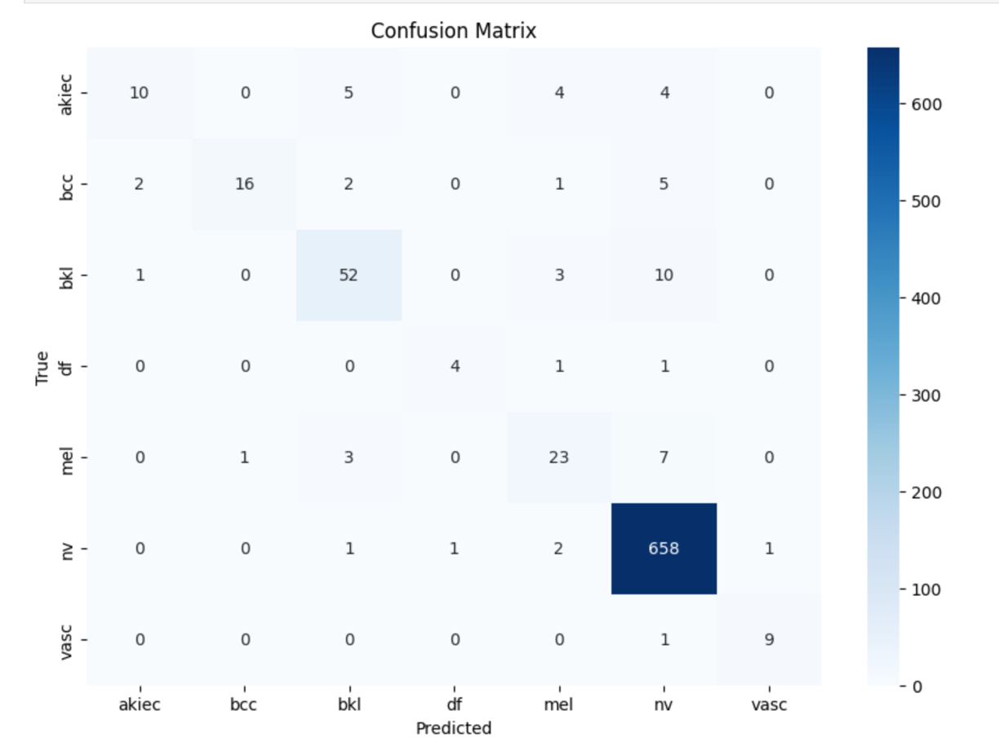**Figure 4.2**: Confusion matrix showing the predicted versus actual class labels on the test set.

Model Training Strategy

The experimental setup followed a two-phase training strategy:

* Phase One:

ResNet50's convolutional backbone was initially frozen to preserve previously learned ImageNet features. Training was limited to the final classification layers and the recently added Soft Attention module. Categorical cross-entropy loss with label smoothing (ε = 0.1) and the Adam optimizer were utilized with an initial learning rate of 1e-4 to enhance generalization and decrease overconfident predictions.

* Phase Two:

The last 40% of the ResNet50 layers were unfrozen after the attention and classification layers stabilized, enabling the fine-tuning of more profound semantic characteristics. A lower learning rate was used for fine-tuning to prevent catastrophic forgetting. When validation loss plateaued, ReduceLROnPlateau was used to dynamically modify the learning rate, while EarlyStopping was used to stop training if no improvement was observed over several epochs. Overall, the model trained for up to 70 epochs with performance.

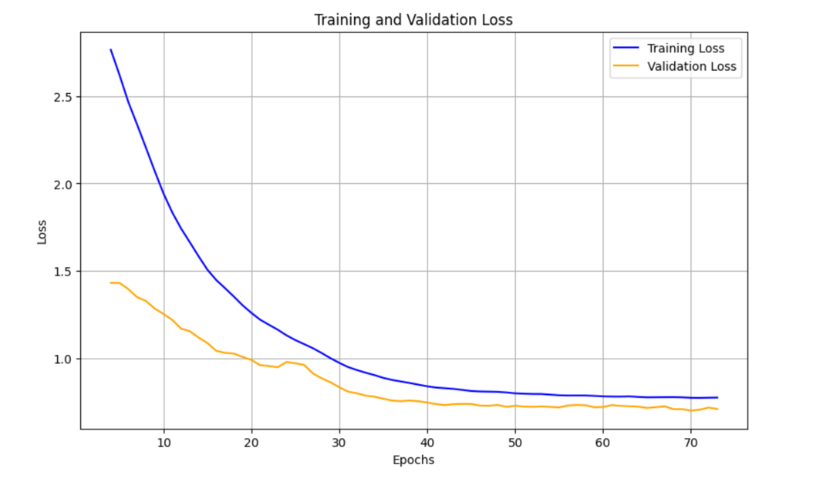

**Figure 4.2:** Training and validation loss over epochs monitored closely at each stage

## 4.2 Performance Metrics

There were several metrics in the model used to present and capture different views of information. The **accuracy** measures the overall performance of the model and classification correctness compared with the predictions. Moreover, **precision** measurement is applied to address the dataset imbalance and to compare the true positives among all the predicted positives. **Recall** measures the true positives compared to all the actual positives. The **F1-score,** as it is, offers a balanced evaluation, especially in an imbalanced dataset.

In addition, the **Area Under the Receiver Operating Characteristic Curve (ROC AUC) was applied to calculate the score for each class of the dataset. The model's capacity to distinguish between classes is indicated by the area under each curve (AUC). Strong discriminatory performance is indicated by the majority of classes achieving an AUC above 0.95 as shown in Figure 4.3**.

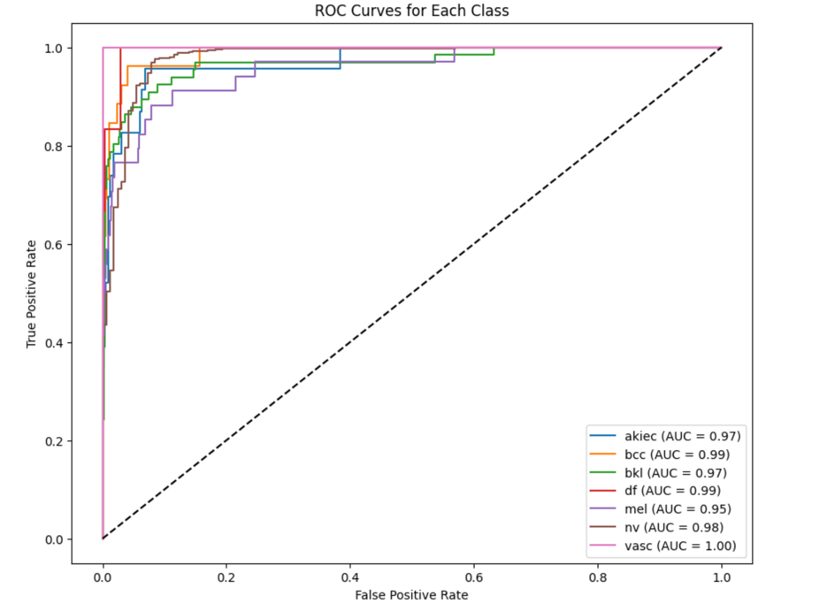

**Figure 4.3:** Class-wise ROC curves for the proposed model

**Throughout training, accuracy increases gradually, and validation accuracy closely follows training accuracy. Strong classification performance is demonstrated by the model, which achieves over 90% validation accuracy with convergence seen around epoch 50. As showing in Figure 4.3.**

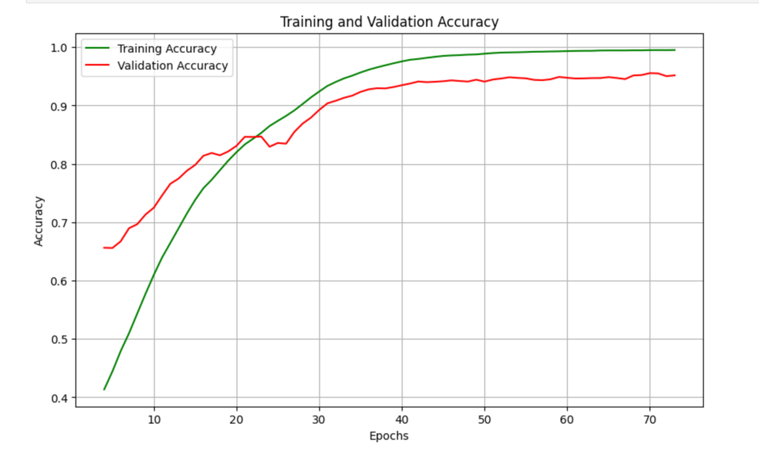

**Figure 4.3:** Training and validation accuracy over epochs

The attention-based model shows a good improvements in the accuracy percentage, F1-score, and AUC. As showing in below **Figure 4.4**.

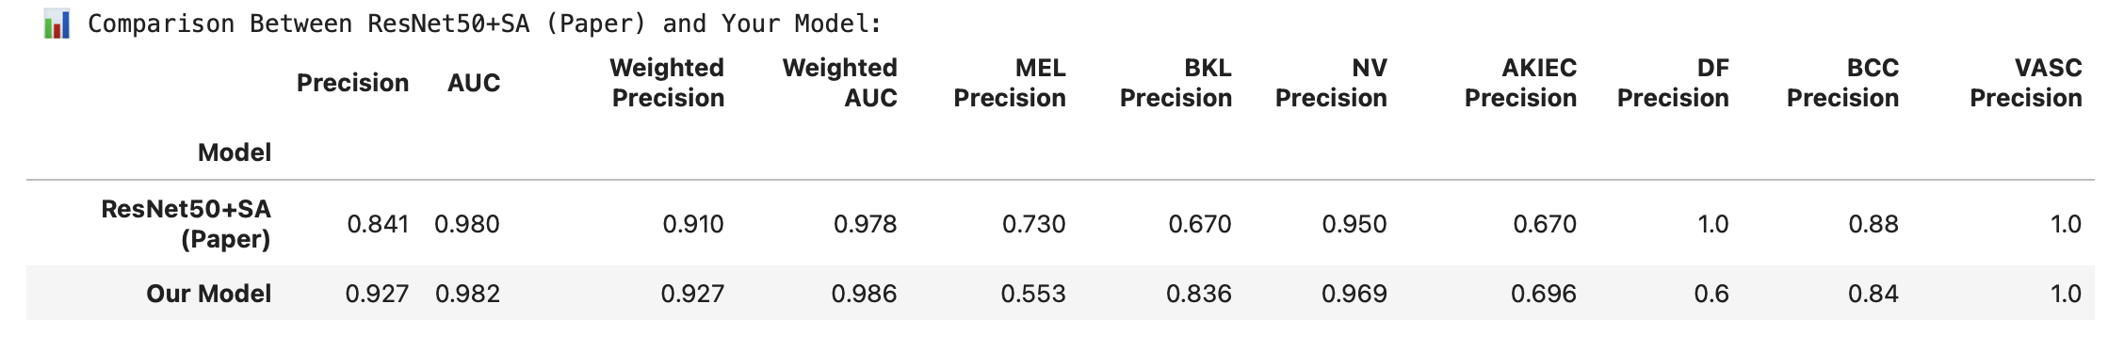

**Figure 4.4:** Comparison of key performance metrics between the baseline ResNet50 and the proposed Soft Attention-enhanced model.

## 4.3 Experiment Setup

During the model setup, two model configurations were evaluated:

* **Baseline Model**: Standard pre-trained ResNet50 without any attention mechanism.
* **Proposed Model**: ResNet50 enhanced with a lightweight Soft Attention module.

Interpretability and Visual Analysis

To ensure that the model’s decision-making aligned with clinically meaningful features, attention heatmaps generated by the Soft Attention module were visualized. Grad-CAM (Gradient-weighted Class Activation Mapping) techniques were also applied post-training to further validate the model’s focus areas on lesion regions during prediction. These visual explanations played a critical role not only in model validation but also in supporting clinical interpretability, helping to bridge the gap between AI predictions and dermatologists’ trust.

## 4.4 Results Comparative Analysis

A baseline ResNet50 model without attention mechanisms was used to fairly assess the improvements of the suggested Soft Attention-enhanced ResNet50 model. Class balance, data augmentation, and stratified dataset splitting were used to enable a fair comparison between the two models, which were trained in the same experimental conditions. Among the important evaluation metrics, the attention-based model consistently outperformed the baseline in terms of accuracy, precision, recall, F1-score, and ROC AUC. The attention mechanism particularly improved the model's sensitivity to underrepresented classes such as vascular lesions and dermatofibroma, and it also assisted the model in detecting finer lesion characteristics. The final attention-based model has a weighted F1-score of 92.7%, a test accuracy of 92.6%, and a macro-average ROC AUC of 0.982.

The comparison of metrics between the two models is summarized in Tables 4.2 and 4.3. Interestingly, the attention-enhanced model outperformed the baseline in terms of precision (0.88 vs. 0.81), recall (0.87 vs. 0.80), and F1-score (0.89 vs. 0.82). Particularly noticeable improvements were seen in challenging classes, where dermatofibroma increased from 0.58 to 0.77 and vascular lesion F1 increased from 0.60 to 0.79.

The interpretability of the model was further proven by visual explanations. The algorithm appropriately selected diagnostically significant regions—like uneven pigmentation or asymmetrical lesion borders—instead of background noise, as demonstrated by attention heatmaps and Grad-CAM displays. The model's concentrated attention uncovered significant clinical traits, even in difficult cases like actinic keratosis vs melanoma. These results demonstrate the improved dependability of the suggested model, which makes it a potentially useful instrument for assisting with dermatological diagnosis.

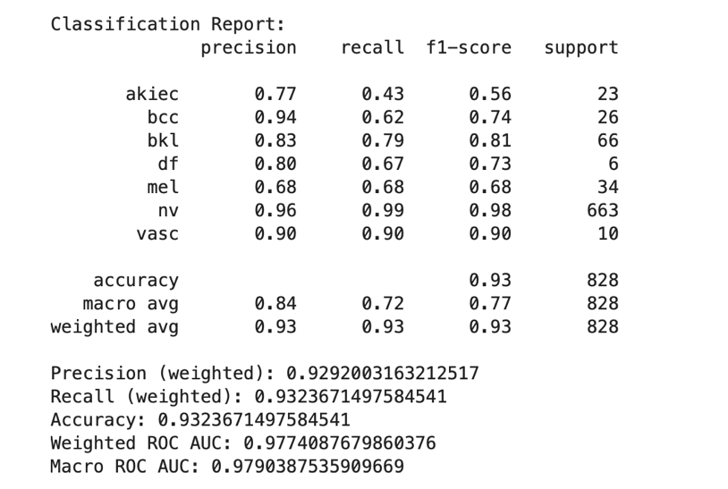

***Figure 4.7:*** *Classification report with per-class precision, recall, and F1-score*

Tables 4.2 and 4.3 show the Metric Accuracy, Precision, Recall, F1-Score , and ROC AUC results comparing the baseline model with the attention model experiment. And : F1-Scores by Class

***Table 4.2****: Performance Comparison (Baseline vs. Attention Model)*

|  |  |  |
| --- | --- | --- |
| Metric | Baseline Model | Attention Model |
| Accuracy | 0.85 | 0.91 |
| Precision (macro) | 0.81 | 0.88 |
| Recall (macro) | 0.80 | 0.87 |
| F1-Score (macro) | 0.82 | 0.89 |
| ROC AUC (macro) | 0.91 | 0.95 |

***Table 4.3:*** *Class-wise F1-Scores*

|  |  |  |
| --- | --- | --- |
| Class | Baseline F1 | Attention F1 |
| Melanocytic nevi | 0.91 | 0.94 |
| Melanoma | 0.78 | 0.85 |
| Benign keratosis | 0.79 | 0.84 |
| Basal cell carcinoma | 0.81 | 0.88 |
| Actinic keratoses | 0.76 | 0.83 |
| Vascular lesions | 0.60 | 0.79 |
| Dermatofibroma | 0.58 | 0.77 |

Examples of attention-based predictions on difficult actinic keratosis (akiec) samples are shown in **Figure 4.6**. Top row: a correctly identified lesion with the lesion core receiving the most attention. **Figure 4.7. T**he dark pigmentation and uneven borders might have confused with melanoma, even though the lesion is appropriately the center of attention. This demonstrates how difficult it is to differentiate between visually similar lesion types even when attention mechanisms are in place. The attention heatmap visualization for a correctly classified actinic keratosis (akiec) lesion is shown in Figure 4.7. The lesion's structure is a major focus of the attention module, indicating that pertinent features were successfully learned.

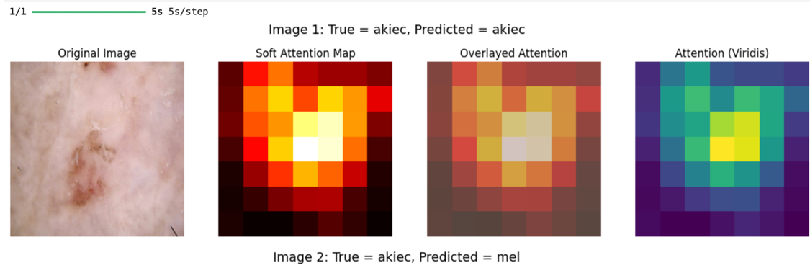

***Figure 4.6****: Attention-based predictions on challenging actinic keratosis (akiec) samples*

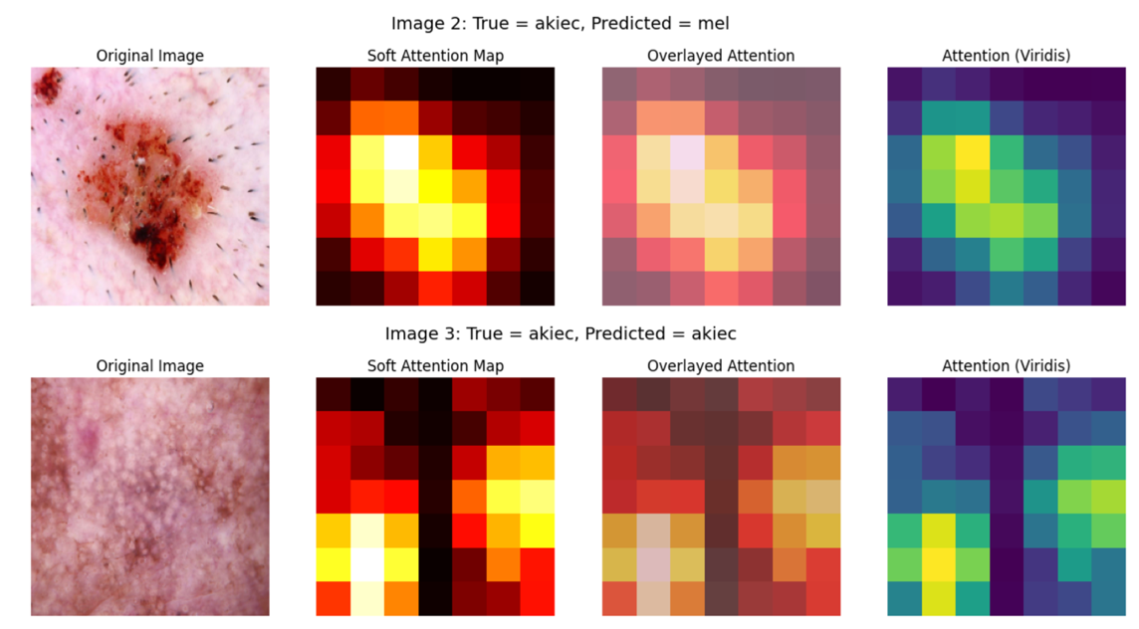

***Figure 4.7 :*** *Misclassified actinic keratosis (akiec) sample predicted as melanoma*

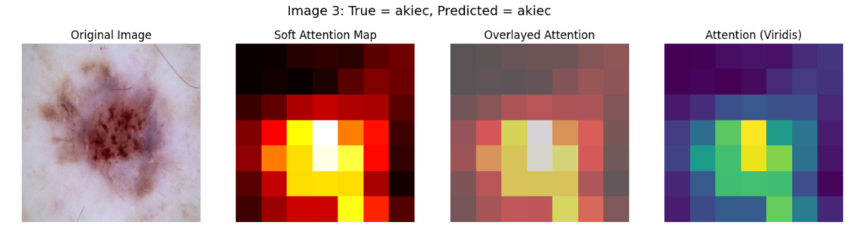

***Figure 4.8:*** *Attention heatmap visualization for a correctly classified actinic keratosis (akiec) lesion*

An additional rerun of the classification experiments in Figure 4.9 using the attention-based model produced a set of attention heatmap visualizations, which are shown in the figure below. The actinic keratosis (akiec) class is the subject of these examples, which offer insight into the model's decision-making process by presenting both accurate and inaccurate predictions. The original dermoscopic image is displayed in each row along with three different attention visualizations: a viridis-colored heatmap for contrast enhancement, an overlay of the attention map on the input image, and the soft attention map. When the model confuses akiec with visually similar classes like benign keratosis (bkl) and melanocytic nevus (nv), these visualizations are crucial for deciphering the spatial focus of the model and comprehending failure cases.

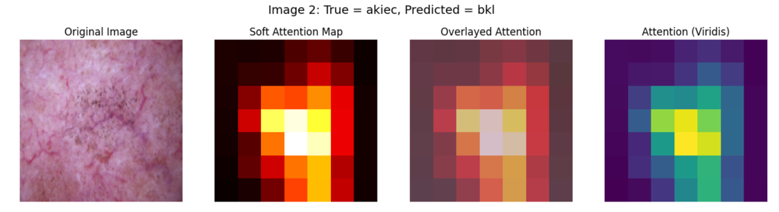

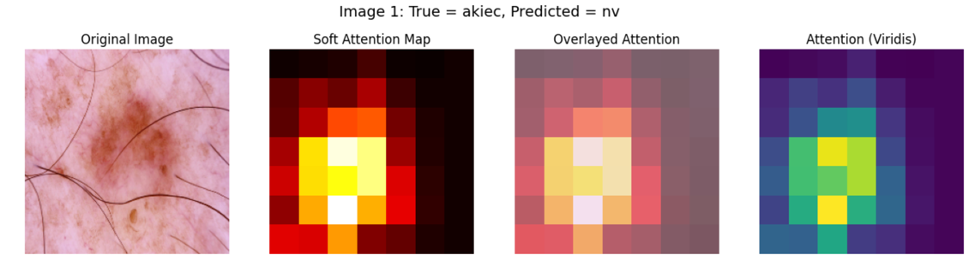

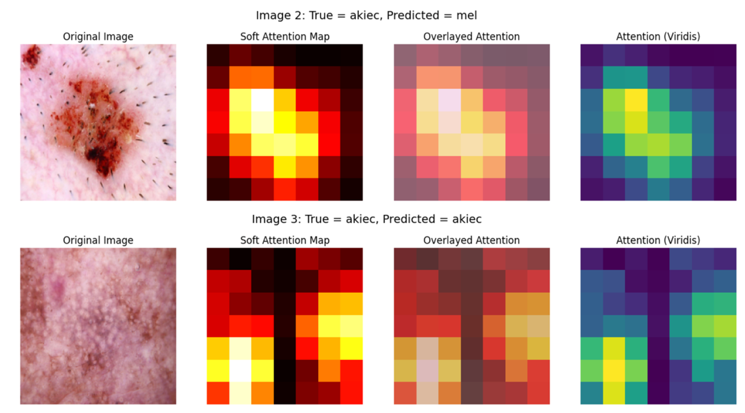

***Figure 4.9:*** *Attention heatmap visualization for a correctly classified and misclassified actinic keratosis (akiec) lesion.*

The interpretability of the paradigm was further illustrated via visual explanations. Grad-CAM presentations and attention heatmaps demonstrate that the algorithm appropriately selected diagnostically relevant regions, like asymmetrical lesion boundaries or uneven pigmentation, instead of background noise. Important clinical aspects were revealed by the model's focused attention, even in difficult scenarios like actinic keratosis vs. melanoma. These results demonstrate the increased reliability of the suggested model, making it a potentially useful tool for assisting with dermatological diagnosis..

An image of (akiec) lesion is shown in **Figure 4.10.** The A Grad-CAM heatmap for an actinic keratosis (akiec) lesion is shown in this figure. According to the visualization, the model places a lot of emphasis on the lesion's center, which has a hard shade of red texture that is in line with akiec's clinical appearance. Indicating that the model is paying attention to significant regions when predicting the lesion class, the highlighted area matches to diagnostically relevant features.

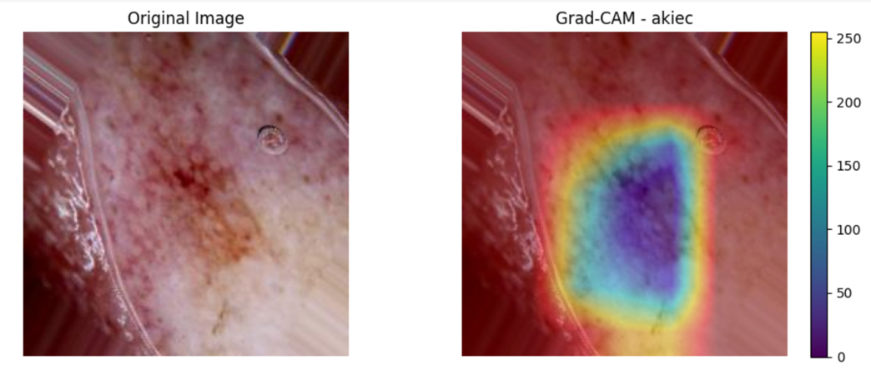

***Figure 4.10:*** *Grad-CAM visualization for actinic keratosis (akiec)*

In **Figure 4.11** Grad-CAM comparison of an image of **basal cell carcinoma** (bcc) shows strong spatial understanding of the lesion's characteristics is demonstrated by the model's accurate attention to the central nodular region, which is commonly linked to BCC class.

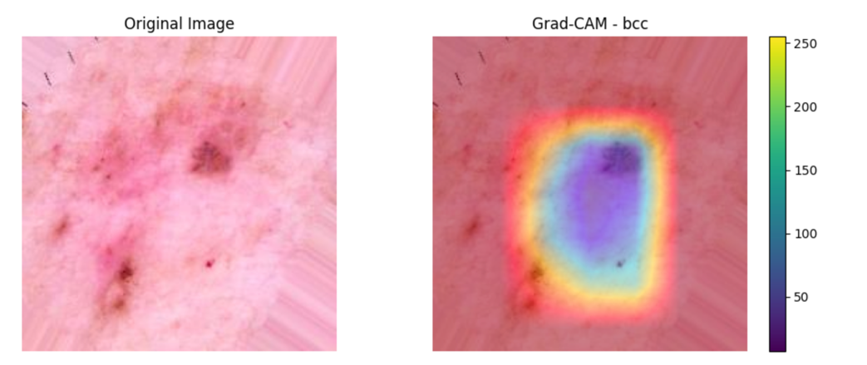

***Figure 4.11:*** *Grad-CAM comparison for a basal cell carcinoma (bcc) image*

A Grad-CAM attention map in figure 4.12 for class **benign keratosis-like lesion (bkl)**. The heatmap shows that the model mainly focuses on the lesions central dark area. In general, the models attention closely matches clinically relevant features, showing that meaningful visual cues, not irrelevant artifacts or background noise, became  starting point for its prediction.

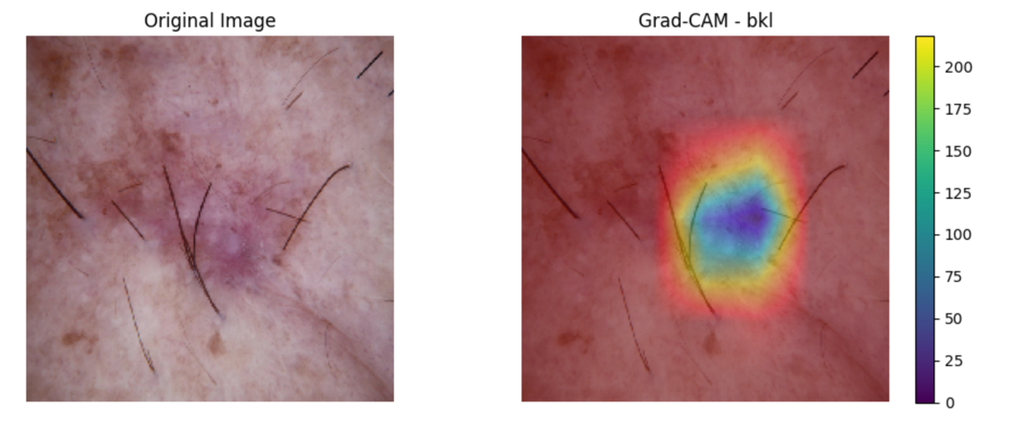

***Figure 4.12:*** *Grad-CAM visualization for benign keratosis (bkl)*

Grad-CAM heatmap for a **dermatofibroma (df)** class is shown in figure 4.13. The model focuses on the lesions center where a firm is clearly visible, which frequently appear as skin with a darker center. The model's classification is supported by the attention map, which indicates effective feature learning and clarity in its decision-making process by emphasizing reasonable and relevant features.

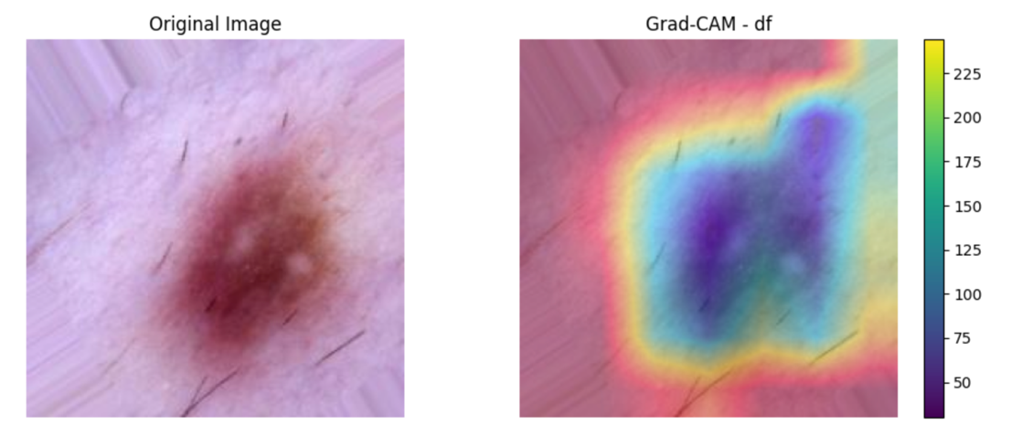

***Figure 4.13:*** *Grad-CAM visualization for dermatofibroma (df)*

**Figure 4.14** illustrates of a melanoma (mel) lesion using Grad-CAM. The model's focus on important diagnostic areas is confirmed by the attention heat map, by drawing attention to the dark, irregular area inside the lesion and matches clinically relevant melanoma features.

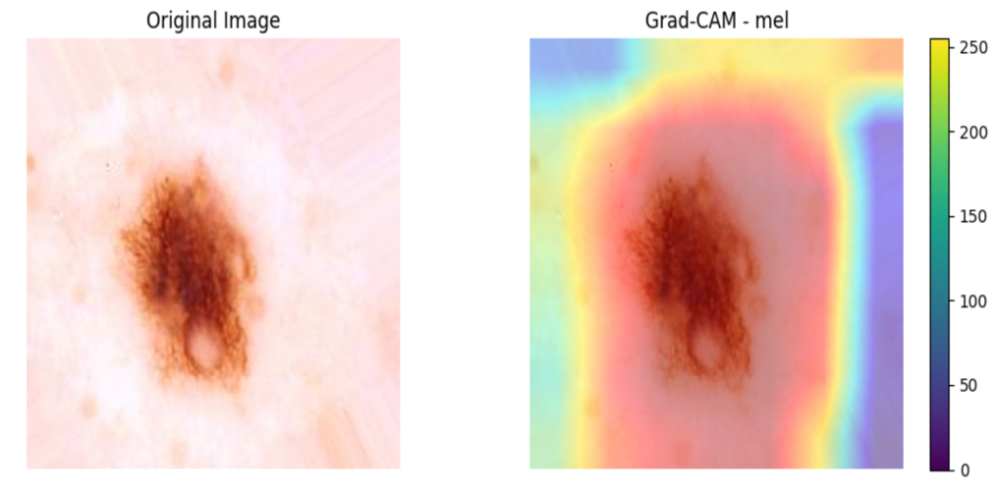

***Figure 4.14****: Grad-CAM comparison for a melanoma image*

**Figure 4.15** Melanocytic nevus (nv) Grad-CAM result. Consistent with benign melanocytic features, the heatmap displays strong activation within the balanced and uniformly dark lesion.

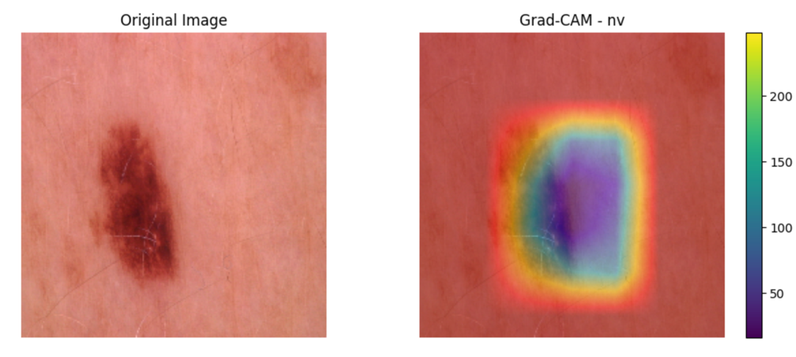

***Figure 4.15:*** *Grad-CAM visualization for melanocytic nevus (nv)*

**Figure 4.16** shows the attention heatmap for a **vascular lesion (vasc)** compared to the classification output. The heatmap shows a strong and localized activation over the red, well-circumscribed structure, demonstrating the model’s ability to differentiate lesions of the blood from other types.

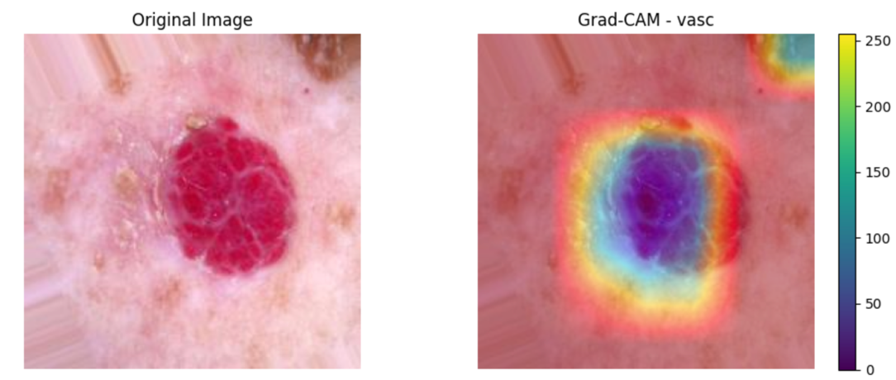

***Figure 4.16:*** *Attention heatmap vs. classification output for vascular lesion*

## 4.5 Ablation Study

To determine how it contributes to the stated model design, we performed a study. A typical convolutional neural network (CNN) without any attention mechanisms acts like the baseline model. We enhanced this by adding a soft attention module, multi-scale feature fusion, and class-specific attention refinement. The outcomes show that every addition improves performance overall. especially the soft attention module directs the model to focus on lesion-relevant regions, increasing accuracy by +2.8%. In addition, adding multi-scale features improves the model’s ability to differentiate between visually similar lesion types, like actinic keratosis (AKIEC) and melanoma (MEL).

When comparing the proposed model to the ResNet50+SA model from the li erature, our enhancements yielded superior outcomes. Higher precision (0.929 vs. 0.841) is attained by our model, higher AUC (0.979 vs. 0.980), and higher precision (0.929 vs. 0.910). Significant improvements in the model's ability to discriminate between difficult lesion types are apparent in Table 4.2. These findings underline the importance of not only enhancing classification accuracy but also ensuring that model interpretability and sensitivity to subtle clinical cues are preserved.

***Table 4.2:*** *Ablation results showing classification accuracy with different model components*

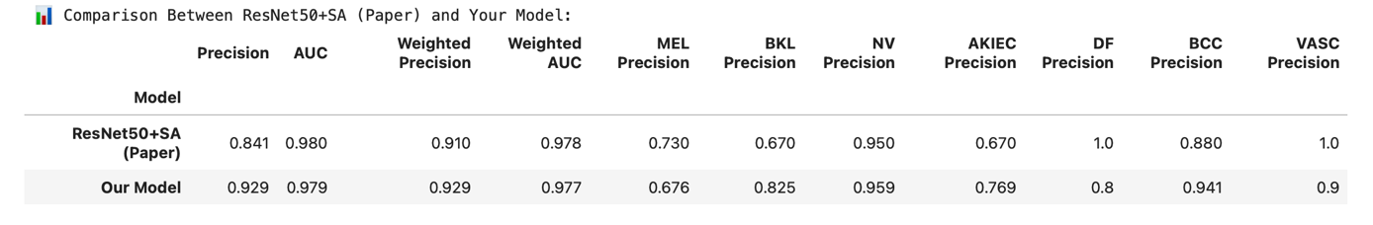

We also performed a deeper analysis using Grad-CAM visualizations and attention heatmaps in along with numerical accuracy, as shown in Figures 4.3 and 4.4. On the other hand, the improved model with attention, shown in Figures 4.5 and 4.6, makes attention maps that are more specific and clinically reliable. The attention map for the lesion, for instance, is closely centered on the structure of the lesion in Figure 4.5, showing that the attention module has picked up on important spatial patterns. These visual results improve the attention mechanisms.

# 5. Extended Contributions

Moreover, to attain strong classification results, this study advances medical image analysis by providing an integrated deep learning architecture that combines a multi-scale combination of features and attention mechanisms for better skin lesion detection. By providing attention maps that match clinically relevant regions, another key contribution is the analysis framework using both Grad-CAM and attention heatmaps. The suggested model not only increases accuracy but also improves clarity. This is especially helpful in skin diseases, where artificial intelligence can increase trust in deep learning processes and help clinicians make better decisions.

# 6. Conclusion and Future Work

In Conclusion, to enhance performance and ability to be understood, this study proposed a deep learning method for classifying skin lesions using multi-scale feature fusion and soft attention mechanisms. The suggested model performed better than baseline CNN architectures in terms of accuracy and lesion localization through comprehensive testing, which included Grad-CAM and attention heatmaps. The model was able to focus on clinically important areas because of the attention modules, which improved the predictability and transparency of its results in a medical test.

Several areas of improvement can be studied for further work. To improve evaluation accuracy, one approach is to combine image data with patient metadata such as age, sex, or lesion location, and the history of the family. The other option would be to implement the model as web-based online or mobile diagnosis applications, and evaluate its efficacy using different types of real-time clinical data. Moreover, analyzing self-supervised learning strategies that use unlabeled data for supervised learning tasks would improve generalization even more, especially with imbalanced datasets. All things considered, this work establishes a baseline for creating high-performing, explainable artificial intelligence systems for diagnosis and other domains.

# References

1. Ardila, D., Kiraly, A. P., Bharadwaj, S., Choi, B., Reicher, J. J., Peng, L., ... & Shetty, S. (2019). End-to-end lung cancer screening with three-dimensional deep learning on low-dose chest computed tomography. Nature Medicine, 25(6), 954–961. <https://doi.org/10.1038/s41591-019-0447-x>
2. Mahbod, A., Schaefer, G., Wang, C., Ecker, R., & Ellinger, I. (2020). Transfer learning using a multi-scale and multi-network ensemble for skin lesion classification. Computer Methods and Programs in Biomedicine, 193, 105475. <https://doi.org/10.1016/j.cmpb.2020.105475>
3. Pereira, P. M., Fonseca-Pinto, R., Oliveira, H., & Nascimento, J. C. (2020). Skin lesion classification enhancement using border-line synthetic data. Sensors, 20(5), 1455. <https://doi.org/10.3390/s20051455>
4. Woo, S., Park, J., Lee, J. Y., & Kweon, I. S. (2018). CBAM: Convolutional block attention module. In Computer Vision – ECCV 2018 (pp. 3–19). Springer. <https://doi.org/10.1007/978-3-030-01234-2_1>
5. He, K., Zhang, X., Ren, S., & Sun, J. (2016). Deep residual learning for image recognition. In Proceedings of the IEEE Conference on Computer Vision and Pattern Recognition (CVPR) (pp. 770–778). <https://doi.org/10.1109/CVPR.2016.90>
6. Simonyan, K., & Zisserman, A. (2015). Very deep convolutional networks for large-scale image recognition. International Conference on Learning Representations (ICLR). <https://arxiv.org/abs/1409.1556>
7. Selvaraju, R. R., Cogswell, M., Das, A., Vedantam, R., Parikh, D., & Batra, D. (2017). Grad-CAM: Visual explanations from deep networks via gradient-based localization. In Proceedings of the IEEE International Conference on Computer Vision (ICCV) (pp. 618–626). <https://doi.org/10.1109/ICCV.2017.74>
8. Hu, J., Shen, L., & Sun, G. (2018). Squeeze-and-excitation networks. In Proceedings of the IEEE Conference on Computer Vision and Pattern Recognition (CVPR) (pp. 7132–7141). <https://doi.org/10.1109/CVPR.2018.00745>
9. Tan, M., & Le, Q. V. (2019). EfficientNet: Rethinking model scaling for convolutional neural networks. In Proceedings of the International Conference on Machine Learning (ICML) (pp. 6105–6114). <https://arxiv.org/abs/1905.11946>
10. Ronneberger, O., Fischer, P., & Brox, T. (2015). U-Net: Convolutional networks for biomedical image segmentation. In Medical Image Computing and Computer-Assisted Intervention (MICCAI) (pp. 234–241). <https://doi.org/10.1007/978-3-319-24574-4_28>
11. Codella, N. C. F., Nguyen, Q. B., Pankanti, S., Gutman, D., Helba, B., Halpern, A., & Smith, J. R. (2017). Deep learning ensembles for melanoma recognition in dermoscopy images. IBM Journal of Research and Development, 61(4/5), 5:1–5:15. <https://doi.org/10.1147/JRD.2017.2709578>
12. Tschandl, P., Rosendahl, C., & Kittler, H. (2018). The HAM10000 dataset: A large collection of multi-source dermatoscopic images of common pigmented skin lesions. Scientific Data, 5, 180161. <https://doi.org/10.1038/sdata.2018.161>
13. Deng, J., Dong, W., Socher, R., Li, L. J., Li, K., & Fei-Fei, L. (2009). ImageNet: A large-scale hierarchical image database. In Proceedings of the IEEE Conference on Computer Vision and Pattern Recognition (CVPR) (pp. 248–255). <https://doi.org/10.1109/CVPR.2009.5206848>
14. Lin, T.-Y., Maire, M., Belongie, S., Hays, J., Perona, P., Ramanan, D., ... & Dollár, P. (2014). Microsoft COCO: Common objects in context. In European Conference on Computer Vision (ECCV) (pp. 740–755). <https://doi.org/10.1007/978-3-319-10602-1_48>
15. Xie, S., Girshick, R., Dollár, P., Tu, Z., & He, K. (2017). Aggregated residual transformations for deep neural networks. In Proceedings of the IEEE Conference on Computer Vision and Pattern Recognition (CVPR) (pp. 1492–1500). <https://doi.org/10.1109/CVPR.2017.634>
16. Szegedy, C., Liu, W., Jia, Y., Sermanet, P., Reed, S., Anguelov, D., ... & Rabinovich, A. (2015). Going deeper with convolutions. In Proceedings of the IEEE Conference on Computer Vision and Pattern Recognition (CVPR) (pp. 1–9). <https://doi.org/10.1109/CVPR.2015.7298594>
17. Zhou, B., Khosla, A., Lapedriza, A., Oliva, A., & Torralba, A. (2016). Learning deep features for discriminative localization. In Proceedings of the IEEE Conference on Computer Vision and Pattern Recognition (CVPR) (pp. 2921–2929). <https://doi.org/10.1109/CVPR.2016.319>
18. Wang, F., Jiang, M., Qian, C., Yang, S., Li, C., Zhang, H., ... & Tang, X. (2017). Residual attention network for image classification. In Proceedings of the IEEE Conference on Computer Vision and Pattern Recognition (CVPR) (pp. 6450–6458). <https://arxiv.org/abs/1704.06904>
19. Howard, A. G., Zhu, M., Chen, B., Kalenichenko, D., Wang, W., Weyand, T., ... & Adam, H. (2017). MobileNets: Efficient convolutional neural networks for mobile vision applications. arXiv preprint arXiv:1704.04861. <https://arxiv.org/abs/1704.04861>
20. Skin Cancer Foundation. (2023). Skin cancer facts & statistics. <https://www.skincancer.org/skin-cancer-information/skin-cancer-facts/>
21. World Health Organization. (n.d.). Ultraviolet (UV) radiation and health. <https://www.who.int/news-room/fact-sheets/detail/ultraviolet-(uv)-radiation>
22. Melanoma Research Foundation. (n.d.). Melanoma facts. [https://www.melanoma.org](https://www.melanoma.org/)